**4) Setup VPC Transist gateway.**

🡪Create different 4 vpc’s

* Create 4 different vpc’s with different IP addresses

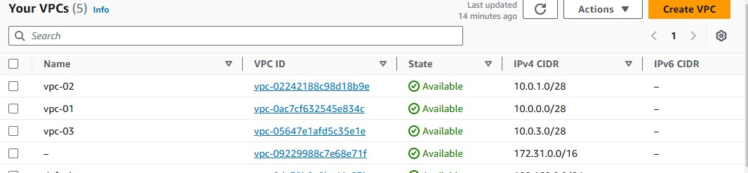

🡪Go to, transist gate way

🡪 Create one transist gate way

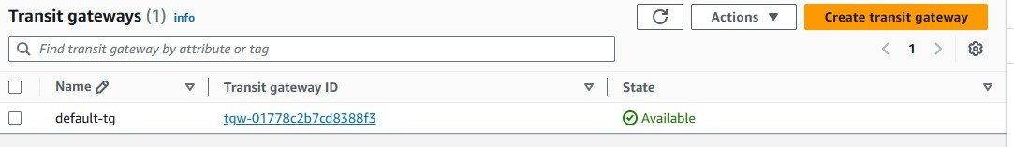

***4 vpc’s with 4 different transist gateway***

🡪 Create vpc’s transist gate way attachment

* + - Name the transist gateway
    - Mention the transist gate way ID that you created
    - Attachment type should be vpc (there are 4 types 1. Vpc 2. Vpn 3. Peering connection 4. Connect)
    - In vpc attachment 🡪 select vpc id (In vpc id 🡪 select the vpc that you created (four different vpc’s) and create the transist gate way attachment
    - Create again with other vpc’s (vpc-02) 🡪 In vpc attachment select the vpc id (i.e.., vpc-02) 🡪 create transist gate way.

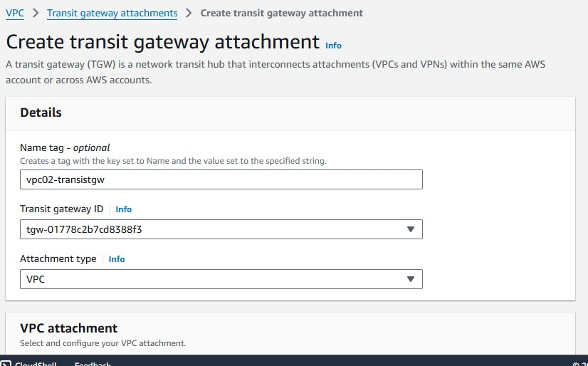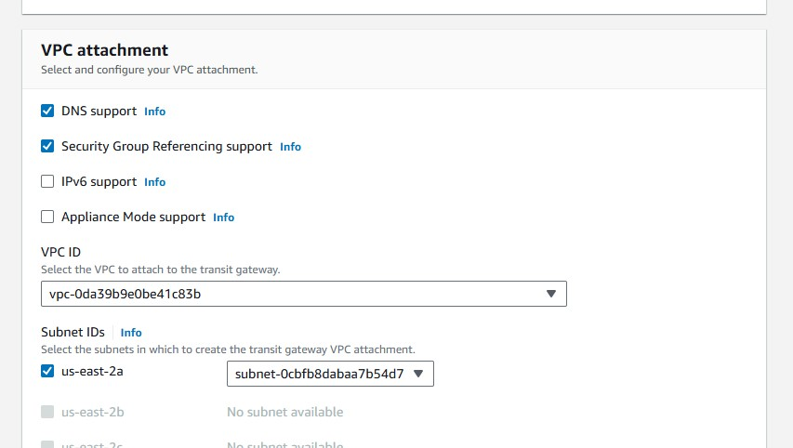

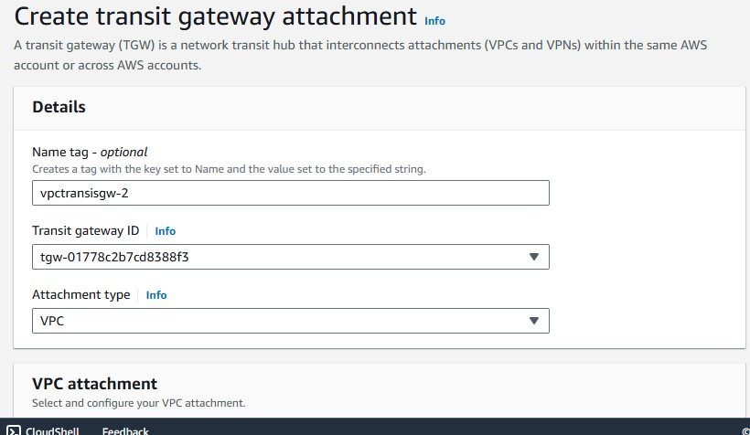

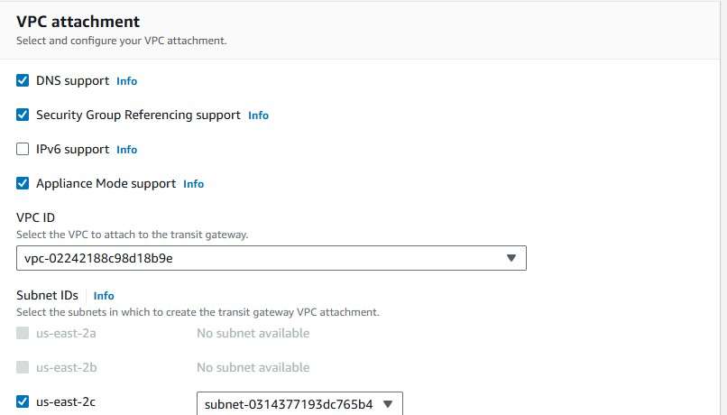

**Create a subnet:**

🡪 Go to, subnet 🡪 create a subnet

🡪 Select the vpc (i.e.., 4 different vpc’s) in that select 1 vpc

🡪Go to; below subnet settings 🡪 mention subnet name 🡪 create ipv4 subnet

* Create a subnet
* Again with other 3 vpc’s with different vpc’s name to identify 🡪 mention ipv4 subnet block

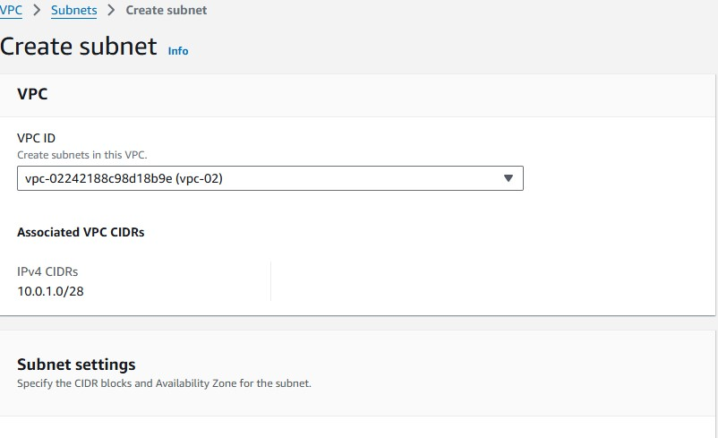

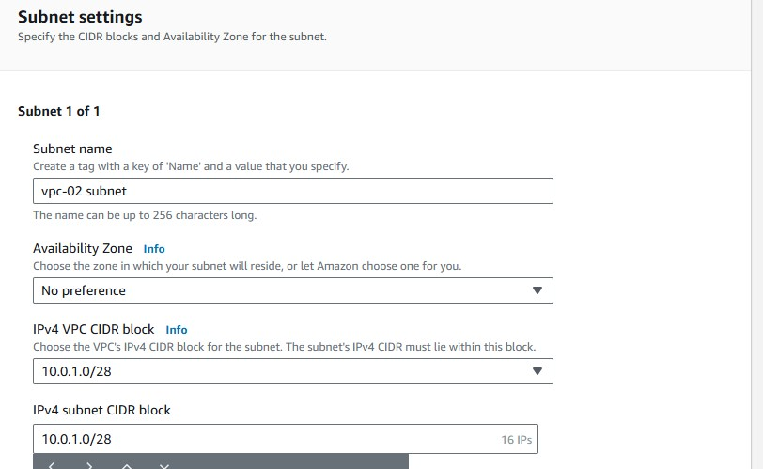

* When creating all subnet it should be like this

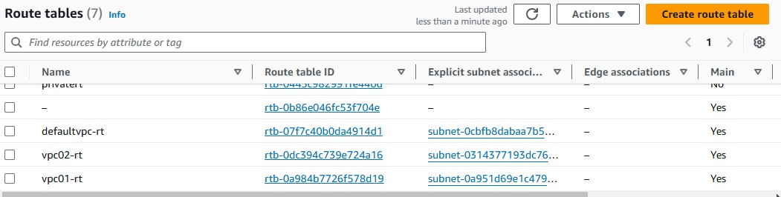

* Go to, route tables 🡪 create route table
* Add vpc id (i.e.., vpc up to 1 to 4) create each subnet with single vpc’s 🡪 create route table
* In vpc select the vpc one by one and create the route table

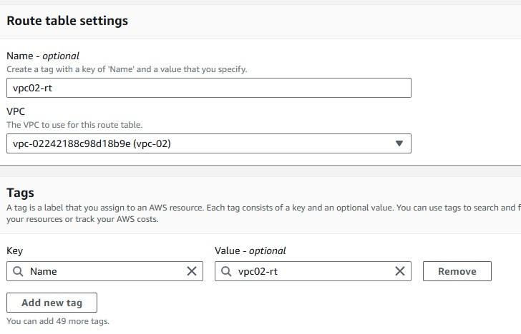

* In route tables, menu it has subnet association 🡪 go to, subnet association 🡪 edit subnet association 🡪 select the subnet 🡪 save the association.
* In route tables, route 🡪edit routes 🡪 add other 3 vpc’s ipv4 address (192.168.0.0/24) 🡪 in target, select the transist gate way, below transist gate way id select 🡪 select add route, again add another vpc ipv4 address and add transist gate way and below add gate way id 🡪 add another vpc ipv4 address 🡪 add transist gate way in target, below transist gate way id 🡪add remaining 🡪 add internet gate way 🡪 this is for only one vpc routing table attachment
* Same again edit route 🡪 add all remaining ipv4 address 🡪 In the same process 🡪 add internet gate way for each routing table.

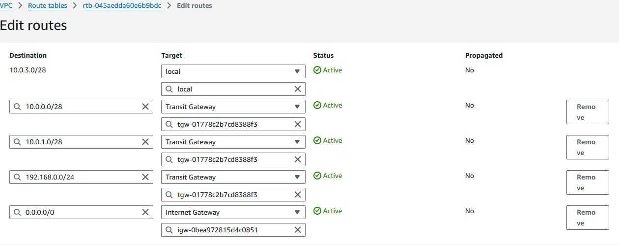

**Open Ec2-instance**

🡪Create a ec2 instance with a name

🡪In network setting 🡪 add vpc 🡪 add subnet that created in vpc

🡪in security group add by default in existing security grp

* Create one instance
* Check the security grp in ec2 console 🡪 check All traffic with ipv4 address
* Add ssh with ipv4 in security grp

Run the instance with ssh authentication.

🡪Same create another instance with another vpc with their subnet

* In console copy the private ip address

🡪 Ping the ip address with other instance which is running if it is running. the connection is established with transist gate way.

